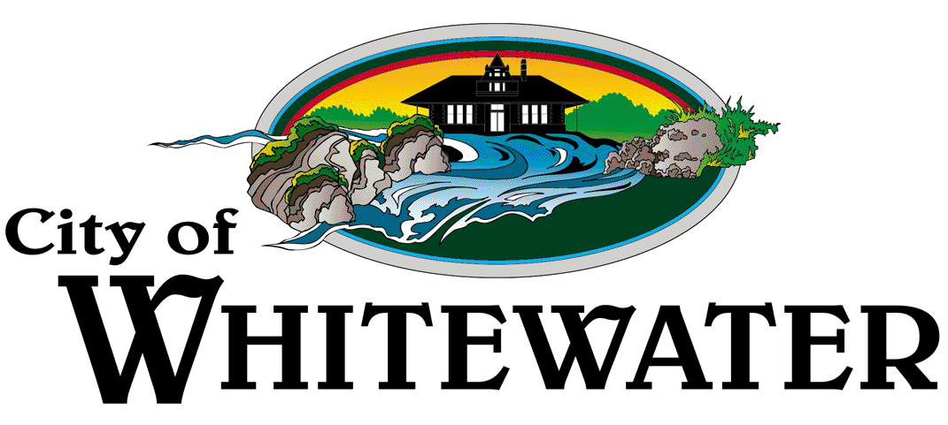
Office of the City Clerk
312 W. Whitewater Street, P.O. Box 178
Whitewater, Wisconsin 53190

www.whitewater-wi.gov
Telephone: (262) 473-0102
Fax: (262) 222-5901

PUBLIC NOTICE

This notice is given to inform the Public that the City of Whitewater is hosting a Community Lakes Meeting with Heidi Bunk, Lakes Biologist, Wisconsin Department of Natural Resources.

The meeting information follows:

When: Wednesday, August 26, 2023, at 11:00am

Where: City of Whitewater Municipal Building, Common Council Chambers Room, 312 W. Whitewater St., Whitewater, WI 53190. Councilmembers and DNR will walk over to Carvath Lake to continue the meeting.

A quorum of the Common Council will be present. This notice is given to inform the public that no formal action will be taken at this meeting. The meeting is open to the public.

Dated: August 21, 2023
Karri Anderberg, City Clerk

